http://abcnews.go.com/US/male-lingerie-model-turns-heads-push-bra/story?id=15154407

Male Model Sports Push-Up Bra in Lingerie Ads
by COLLEEN CURRY
ABC News / December 14, 2011

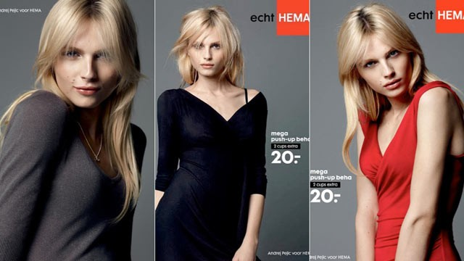

The latest tall, blonde model to turn heads in a push-up bra is causing the fashion world to do a double-take. The star of a new lingerie ad campaign is a man!

Andrej Pejic -- a 20 yr-old male model known for his gender-bending work on runways -- is the star of Dutch fashion company Hema's newest lingerie ad campaign. In it, Pejic dons the push-up bra, a skin-tight dress that hugs his newly curvy body, and dramatic, smoky-eyed makeup. With long-blonde hair, lip gloss, and delicate features, the 6'1" Pejic strikes a very feminine figure.

Hema, the company that hired Pejic, said in a statement on their website that the ad campaign demonstrates that even a man can gain curves with the use of the bra.

"Even men get a decolleté with this new mega push-up bra," the statement says in translation. "That means that you with 'totally nothing' can go to a beautiful B-cup."

Pejic, who was born in Bosnia-Herzegovina and raised in Australia, has gained fame in the fashion world for his work in both men's and women's fashion, modeling both bridal gowns and tuxedos, men's underwear and -- now -- women's underwear, too.

"He's rare. No one looks like him," photographer Chris Benz told ABC News. "I mean no one. None of the boys look like him. None of the girls look like him. It's just him. It's Andrej."

Pejic, who wears a women's size 2 or 4, told ABC News in September that his sexiest features are his hip, and that the toughest part of his job is squeezing into size-11 high-heeled shoes.

"I don't really have that sort of strong gender identity. I identify as what I am," Pejic told New York Magazine in August. "The fact that people are using it for creative or marketing purposes, it's just kind of like having a skill and using it to earn money."

Pejic now commands as much money as a female model would for photo shoots. His face has graced the covers of more high fashion magazines than any other male model.

According to his agent Joseph Tenni, Pejic's role as a women's underwear model has broken down gender roles in the fashion world in an unprecedented way.

"It's revolutionary," Tenni told the Australian blog frockwriter. "I've never known a man to do a woman's lingerie campaign before."

The bras, which have received worldwide attention from their unique model, retail at 20 euro (about $25). They promise an increase of at least 2 cup sizes to the average wearer.

http://models.com/models/andrej-pejic/5
Father is Croatian, mother is Serbian. From WWD profile December 20, 2010: "Since the fashion industry first began asking “Who’s the blonde girl?” at the Paris men’s shows in June (2010), 19-year- old Serbian Australian model Andrej Pejic has emerged as a poster boy for fashion androgyny. His long, platinum-blonde hair and feminine features caught the attention of (among others) Steven Meisel and Mert Alas and Marcus Piggott.

Jean Paul Gaultier not only booked Pejic for his spring 2011 men’s show but he also cast him in his spring ad campaign alongside Czech supermodel Karolina Kurkova. Now it looks like Marc Jacobs may also be going the guess-the-gender route for his Marc by Marc Jacobs spring campaign.

Pejic recently returned from shooting the ads in Marrakech with Juergen Teller alongside look-alike Latvian (female) model Ginta Lapina. Born in Tuzla, Bosnia and Herzegovina, Pejic and his family fled the war-torn region in the 1990s before settling as refugees in Melbourne, Australia.

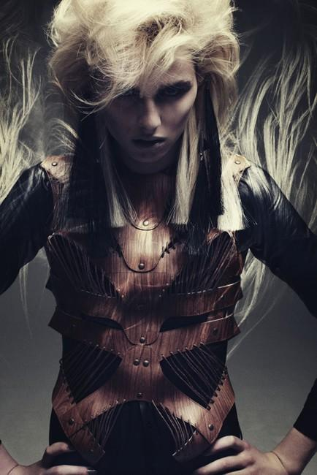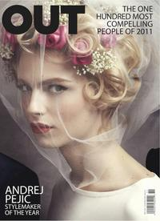
Sid Magazine, Dec 2011 Sid Magazine, Dec 2011 OUT Magazine, Dec 2011

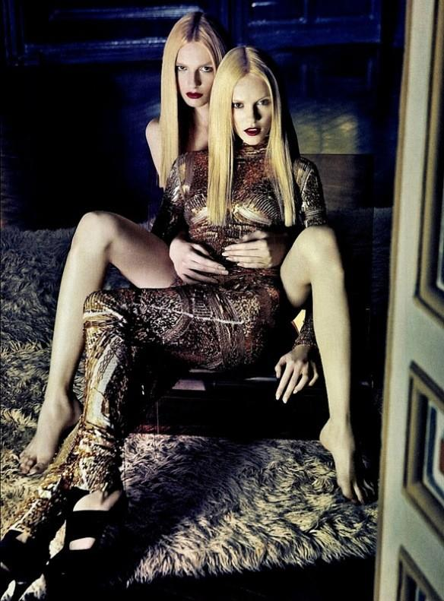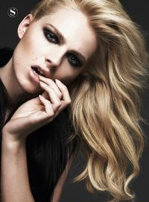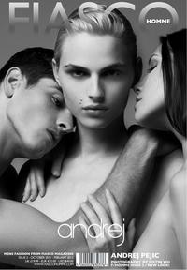
Les gemeaux, Nov 2011 Andrej by Jonas for El Pais S Moda Fiasco Magazine, Oct 2011
Oct 2011

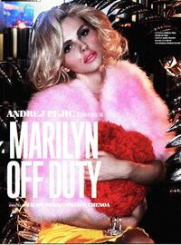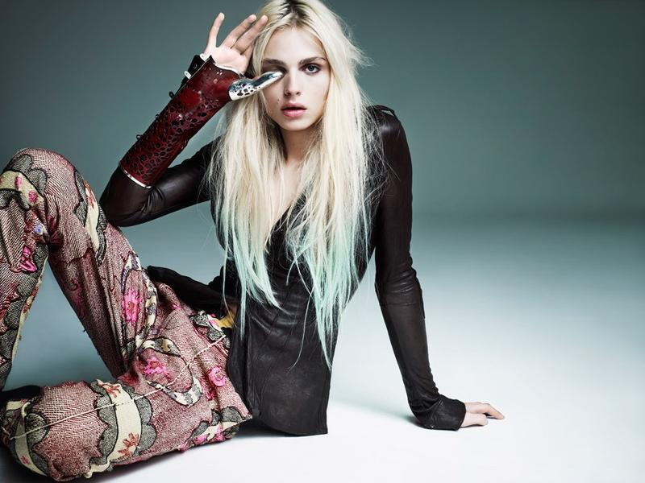
Lovecat (editorial) Viva! Moda , Aug 2011 Follow , Aug 2011
Fall/Winter 2011

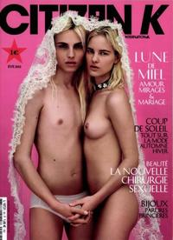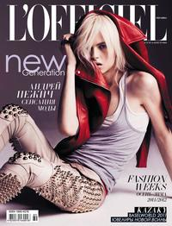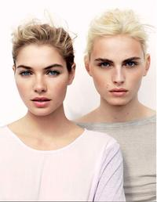
Citizen K, July 2011 L'Officiel Ukraine, June 2011 Vogue Australia, April 2011

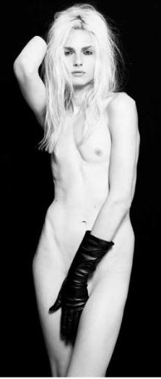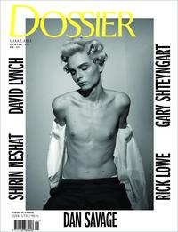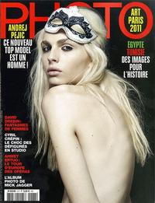
BMM Magazine Dossier S/S 11 Photo France, March 2011
Spring/Summer 2011 Spring/Summer 2011

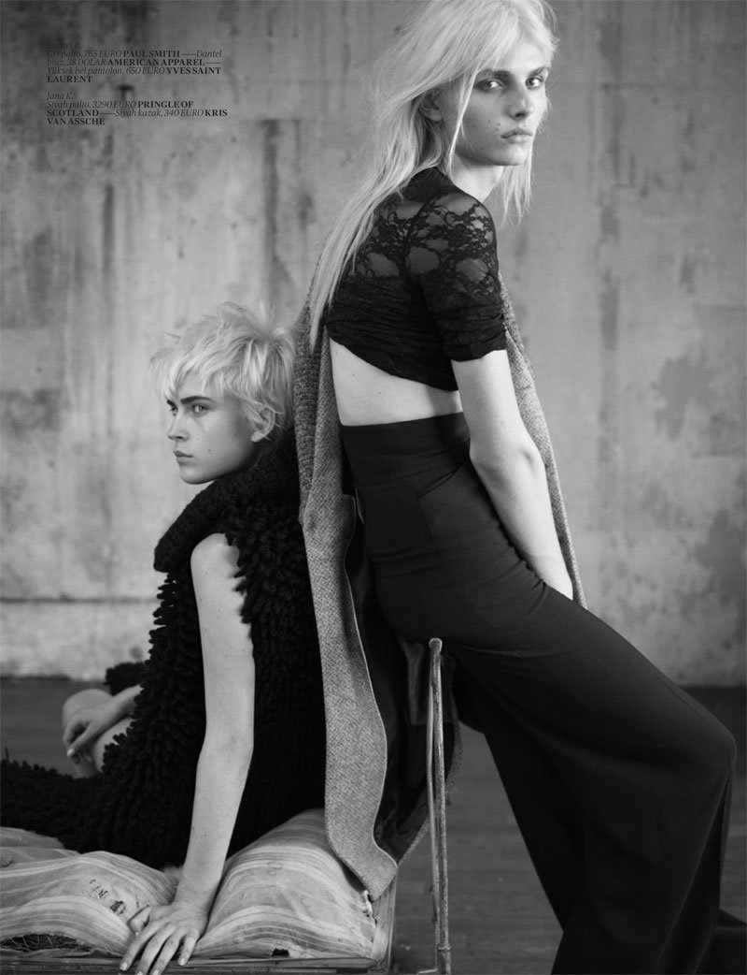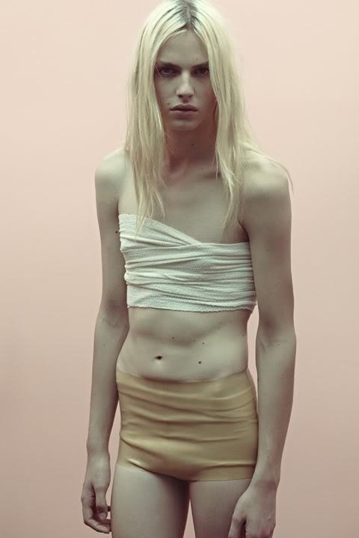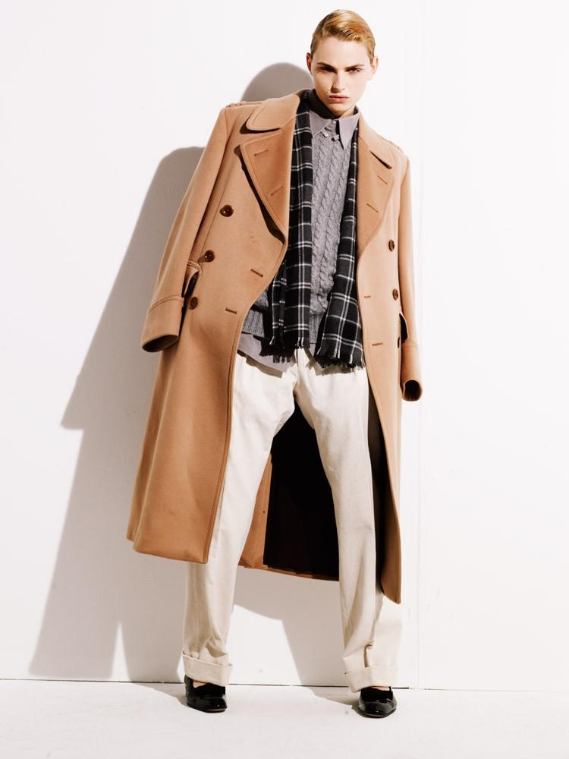
Vogue Turkey, Nov 2010 Candy Magazine Apropos, Spring/Summer 2010
Fall/Winter 2010

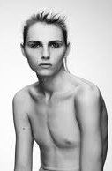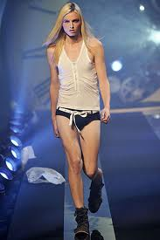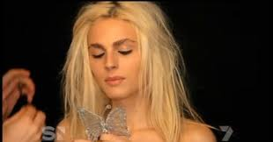

http://abcnews.go.com/blogs/entertainment/2013/01/elle-puts-androgynous-model-andrej-pejic-on-a-cover/#.UOcVqhB03TE.email
Elle Puts Androgynous Model Andrej Pejic on Its Cover
by Jennifer Abbey
ABC News Entertainment / Jan 3, 2013

For the first time, an androgynous model has landed on the cover of Serbian Elle.
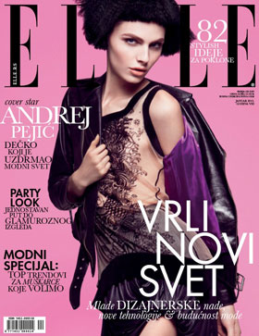

Andrej Pejic is a 6’1” male model who models both men’s and women’s fashions. A t New York Fashion Week in February 2011, he walked in 5 shows for men and four for women. The 21-year-old has become a muse for Jean Paul Gaultier who has described Pejic’s look as “otherworldly beauty.”

Born in Bosnia shortly before the Bosnian War, Pejic immigrated to Australia with his family when he was 8. He was discovered in Melbourne, Australia, but told he would have difficulty finding work. After graduating from high school, Pejic moved to London and his career took off when he began posing as both male and female.
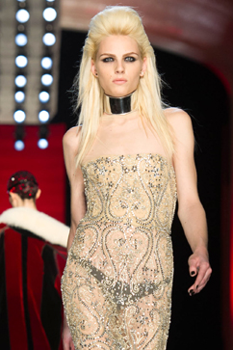

“I guess professionally I’ve left my gender open to artistic interpretation,” he told New York magazine in 2011.

Pejic, who’s modeled for French Vogue, shocked the world in May 2011 when he appeared shirtless on the cover of Dossier Journal. Barnes&Noble covered the magazine in stores because it was considered scandalous.

In the Elle shoot, Pejic models both male and female looks, dressed in head-to-toe Gaultier, according to the New York Daily News. Pejic is known for his long, platinum blonde locks. But he trades them in on the cover for a black bob.

“I know people want me to sort of defend myself, to sit here and be like ‘I’m a boy but I wear makeup sometimes.’ But, you know, to me it doesn’t really matter,” Pejic told New York Magazine. “I don’t really have that sort of strong gender identity. I identify as what I am.”

also related: the World's Most Beautiful Transsexual?
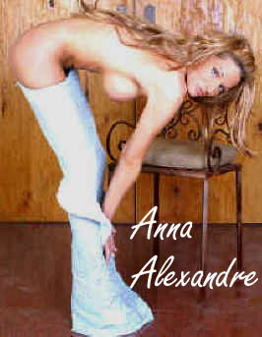
Anna Alexandre => http://www.hotlegsinlove.com/Anna.htm

